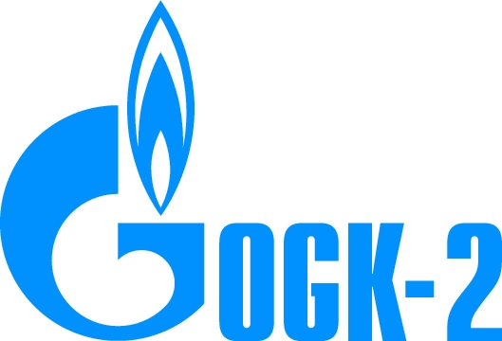
RELEASE
April 25, 2012
Moscow

OJSC OGK-2: 2011 IFRS Results
OJSC OGK-2 releases its audited consolidated Financial Statements for the year 2011, prepared in accordance with International Financial Reporting Standards (IFRS). The OJSC OGK-2 2011 Financial Statements include the OJSC OGK-2 and OJSC OGK-6 operating results before OJSC OGK-2’s reorganization in the form of consolidation with OJSC OGK-6, accomplished by November 1, 2011.
Consolidated Statement of Comprehensive Income Highlights (mn RUR) | 2011 | 2010 (revised)**
Revenue | 104,896 | 96,463
Operating expenses | (102,366) | (89,137)
Operating profit | 2,218 | 7,359
EBITDA* | 5,900 | 10,544
Profit for the year | 10 | 4,670
* EBITDA= Operating profit + Depreciation and Amortization.
** The summarized OGK-2 and OGK-6 data revised for consolidated company.
In the year 2011 the revenue of OJSC OGK-2 totaled RUR 104,896 mn, which is 9% higher year-on-year, despite the electricity output 3.2% lowering. The revenue increase resulted mostly from the growth of weighted average tariffs and prices at the wholesale market for electricity and capacity, and, above all, at the “day-ahead market”.
In the year 2011 operating expenses increased by 15% year-on-year and reached RUR 102,366 mn. Expenses for fuel, purchased electricity, heat and capacity, which grew by 13% up to RUR 72,150 mn, dominate the operating expenses structure.
Hence, operating profit for the year 2011 totaled RUR 2,218 mn.
EBITDA for the year 2011 totaled RUR 5,900 mn. Profit for the year – RUR 10 mn.
Detailed information about OGK-2 performance in the year 2011 in accordance with IFRS is available at the company’s website in the IFRS Financial Reports section.
For reference:
On November 1, 2011 corporate procedures on OGK-6 consolidation to OGK-2 were concluded.
As a result of the consolidation all rights and liabilities of OGK-6 were transferred to OGK-2. Shares of OGK-6 were converted into additional shares of OGK-2, floated by the means of conversion. 1.2141 common nominal uncertificated shares of OGK-6 with nominal value of RUR 0.48 corresponded to 1 common nominal uncertificated share of OGK-2, with nominal value of RUR 0.3627.
As a result of the consolidation of OGK-6 to OGK-2 a leading heat generator was created, comprising 10 branches - power plants and Adlerskaya TPS (under construction) with total installed capacity of c. 17.9 GW (after the commissioning of CCGT-800 of Kirishskaya GRES – 18.4 GW), providing about 8% of the electricity output in Russia.
The Company includes: Adlerskaya TPS, Kirishskaya State District Power Plant, Krasnoyarskskaya State District Power Plant 2, Pskovskaya State District Power Plant, Novocherkasskskaya State District Power Plant, Ryazanskaya State District Power Plant, Serovskaya State District Power Plant, Stavropolskaya State District Power Plant, Surgutskaya State District Power Plant 1, Troitskskaya State District Power Plant, Cherepovetskaya State District Power Plant.

The Company’s controlling shareholder is ‘Gazprom Energoholding’ LLC (100% subsidiary of ‘Gazprom’ OJSC).

PR AND MEDIA DEPARTMENT
www.ogk2.ru
www.ogk6.ru
____________________________________________________________________

Contacts for Media:
+7 (495) 428 53 07
filatovde@ogk2.ru

